**Vendor Sales Summary Report**

**Exploratory Data Analysis**

**Summary Statistics**

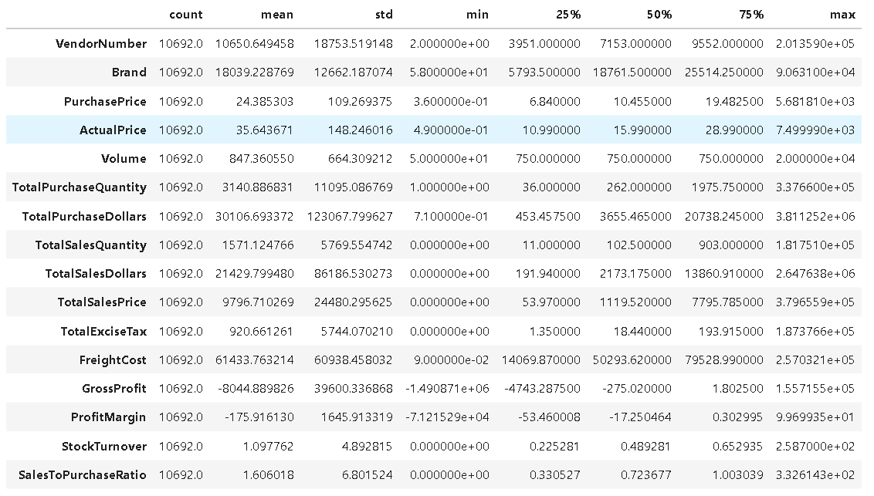

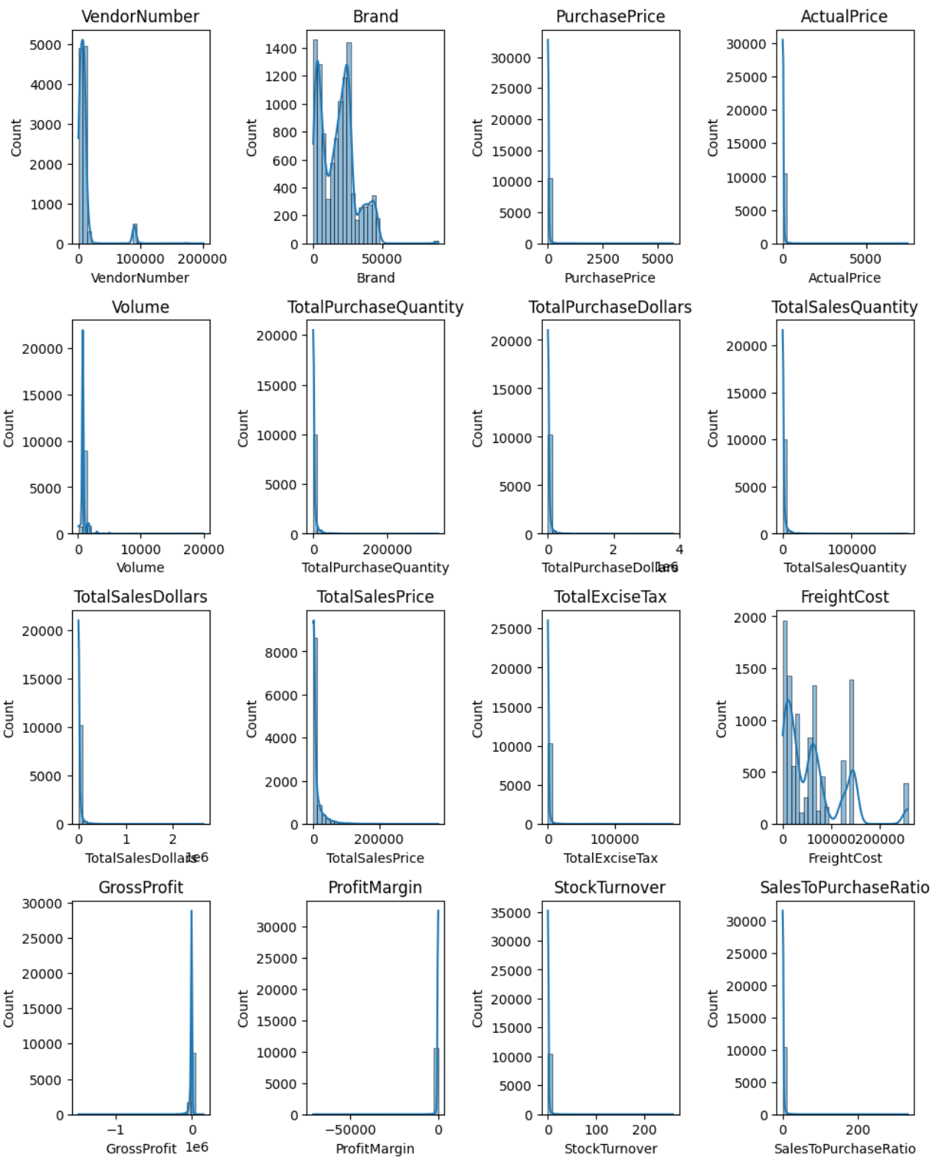

**Negative and Zero Values**

**Gross Profit:** Minimum of -1490871, indicating potential losses due to high costs or heavy discounts. This could be due to selling products at lower prices than their purchase costs.

**Profit Margin:** Has a minimum of -∞ / -7121529, which suggests instances where revenue is zero or even lower than the total cost, leading to extreme negative profit margins.

**Total Sales Quantity & Sales Dollars:** Some products show zero sales, indicating they were purchased but never sold. These may be slow-moving or obsolete stock, leading to inventory inefficiencies.

**Outliers Detected by High Standard Deviations:**

**Purchase & Actual Prices:** The maximum values (5,681.81 & 7,499.99) are significantly higher than the mean (24.39 & 35.64), indicating premium product offerings.

**Freight Cost:** Extreme variation from 0.09 to 257,032.1 suggest logistics inefficiencies, bulk shipments or erratic shipment costs across different products.

**Stock Turnover:** Ranges from 0 to 258.7, suggesting some products sell rapidly while other remain unsold for long periods. A value greater than 1 indicates that sales for a product exceed the product quantity due to older stock fulfilling orders.

**Data Filtering**

To enhance the reliability of insights, we removed inconsistent data points where:

* Gross Profit <= 0 (to exclude transactions leading to losses).
* Profit Margin <= 0 (to ensure analysis focuses on profitable transactions).
* Total Sales Quantity = 0 (to eliminate inventory that was never sold).

**Correlation Insights**

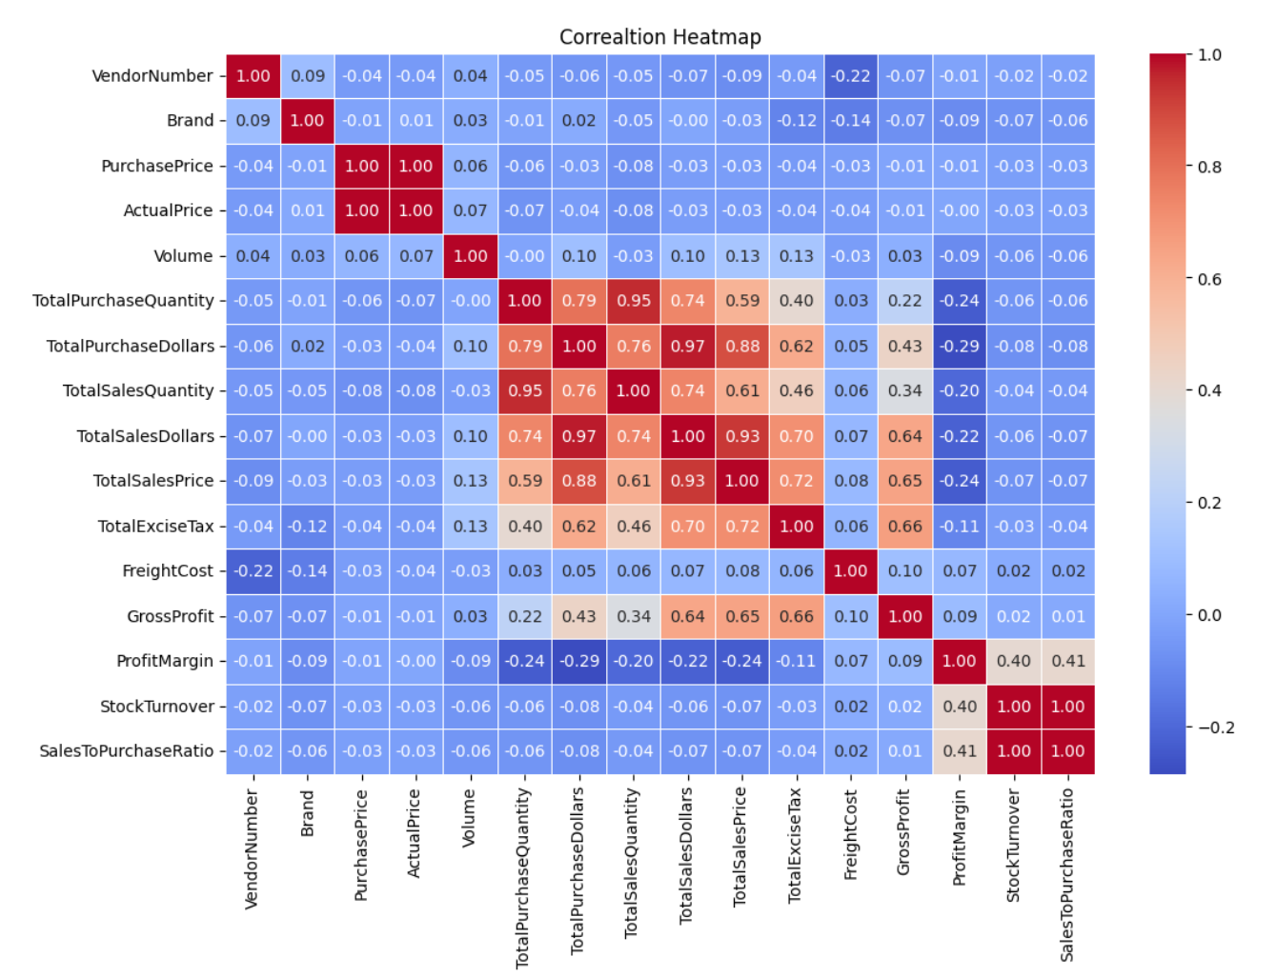

**Purchase Price vs. Total Sales Dollars & Gross Profit:** Weak correlation (-0.03 and -0.01), indicating that price variations do not significantly impact sales revenue or profit.

**Total Purchase Quantity vs. Total Sales Quantity:** Strong correlation (0.95), confirming efficient inventory turnover.

**Profit Margin vs. Total Sales Price:** Negative correlation (-0.24), suggesting increasing sales prices may lead to reduced margins, possibly due to competitive pricing pressures.

**Stock Turnover vs. Gross Profit & Profit Margin:** Weak correlation (0.02 & 0.40), indicating that faster stock turnover does not necessarily equate to higher profitability.

**Research Questions & Key Findings**

1. **Brands for Promotional or Pricing Adjustments**

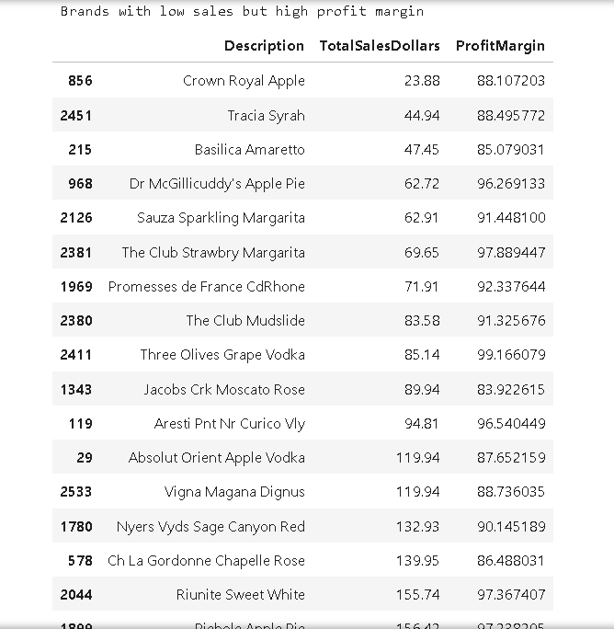

35 brands exhibit lower sales but higher profit margins, which could benefit from targeted marketing, promotions, or price optimizations to increase volume without compromising profitability.

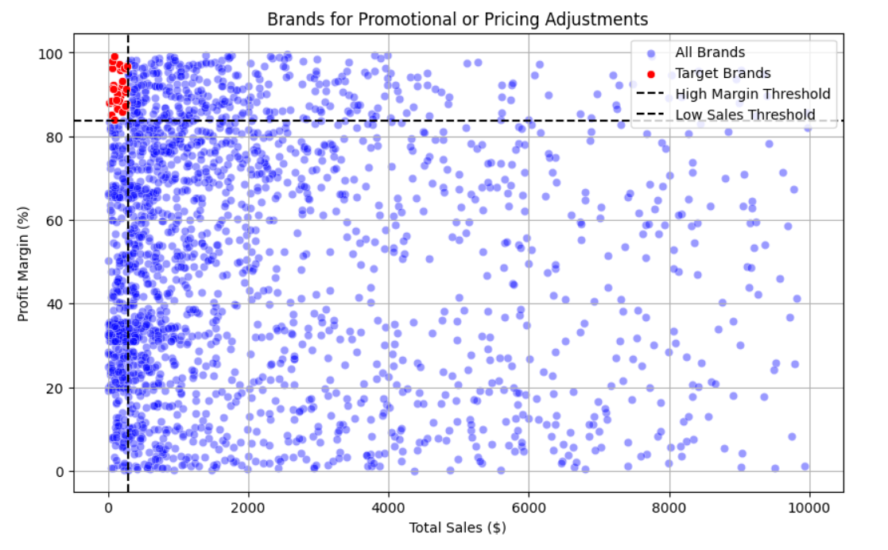

1. **Top Vendors by Sales & Purchase Contribution**

The top 10 vendors contribute 66.11% of total purchases, while the remaining vendors contribute only 33.8%. This over-reliance on few vendors may introduce risks such as supply chain disruptions, indicating a need for diversification.

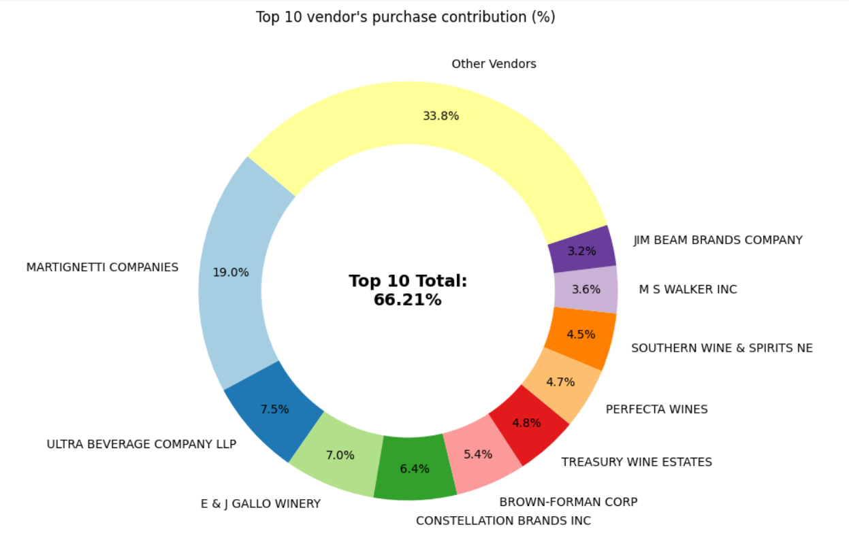

1. **Impact of Bulk Purchasing on Cost Savings**

Vendors buying in large quantities receive a 72% lower unit cost ($11.46 per unit vs. higher unit cost in smaller orders).

Bulk pricing strategies encourage larger orders, increasing total sales while maintaining profitability.

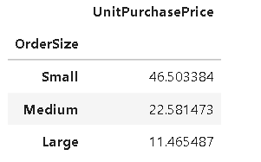

1. **Identify Vendors with Low Inventory Turnover**

Total Unsold Inventory Capital: $ 1.29M

Slow-moving inventory increases storage costs, reduces cash flow efficiency, and affects overall profitability.

Identifying Vendors with low inventory turnover enables better stock management, minimizing financial strain.

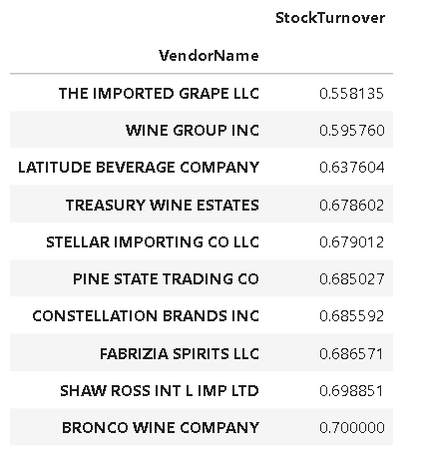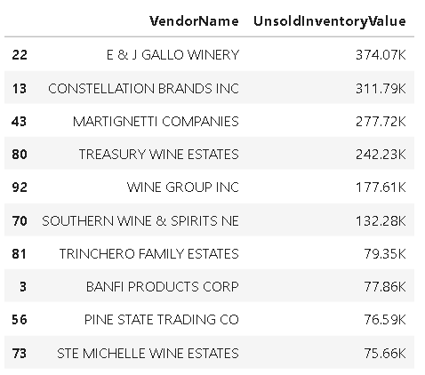

1. **Profit Margin Comparison: High vs. Low-Performing Vendors**

**Top Vendors' Profit Margin (95% CI):** (32.92%, 37.17%), Mean: 35.04%

**Low Vendors' Profit Margin (95% CI):** (44.28%, 48.20%), Mean: 46.24%

Low-performing vendors maintain higher margins but struggle with sales volumes, indicating potential pricing inefficiencies or market reach issues.

**Actionable Insights:**

* **Top-performing vendors:** Optimize profitability by adjusting pricing, reducing operational costs, or offering bundled promotions.
* **Low-**performing vendors: Improve marketing efforts, optimize pricing strategies, and enhance distribution networks.

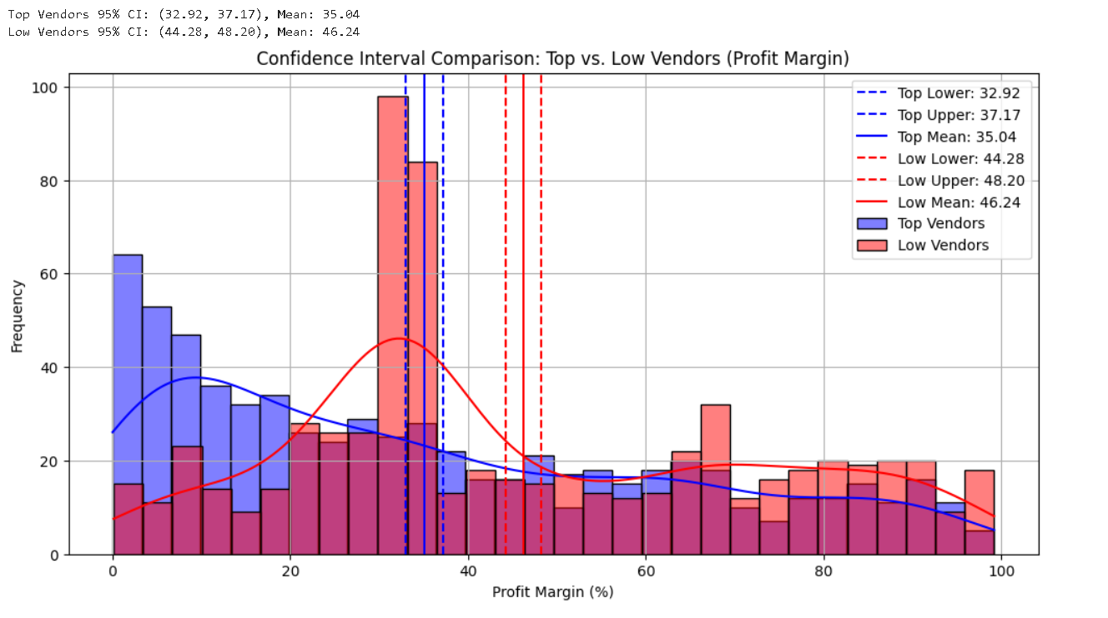

**6. Statistical Validation of Profit Margin Differences**

**Hypothesis Testing:**

**H₀ (Null Hypothesis):** No significant difference in profit margins between top and low-performing vendors.

**H₁ (Alternative Hypothesis):** A significant difference exists in profit margins between the two vendor groups.

**Result:** The null hypothesis is rejected, confirming that the two groups operate under distinctly different profitability models.

**Implication:** High-margin vendors may benefit from better pricing strategies, while top-selling vendors could focus on cost efficiency.

**Final Recommendations**

* Re-evaluate pricing for low-sales high-margins brands to boost sales volume without sacrificing profitability.
* Diversify vendor partnerships to reduce dependency on a few suppliers and mitigate supply chain risks.
* Leverage bulk purchasing advantages to maintain competitive pricing while optimizing inventory management.
* Optimize slow-moving inventory by adjusting purchase quantities, launching clearance sales, or revising storage strategies.
* Enhance marketing and distribution strategies for low-performing vendors to drive higher sales volumes without compromising profit margins.
* By implementing these recommendations, the company can achieve sustainable profitability, mitigate risks, and enhance overall operational efficiency.